What are the consequences of being bilingual? Controversy exists in the field regarding the impact of bilingualism on cognition. Some research suggests there are advantages for bilinguals in cognitive flexibility, memory, and metalinguistic ability but costs associated with language processing. Other researchers report no differences. In this seminar, we will discuss bilingualism topics with an emphasis on understanding the cognitive mechanisms involved.

## In this course, you will

## Learn…

1. about the basic questions and terminology related to cognition and bilingualism
2. to evaluate empirical studies in terms of their scientific and methodological aspects
3. how to read, analyze and use information found in contemporary scientific articles.

## Explore & Evaluate…

different methods of “measuring” bilingualism

## Understand & Discuss…

the debates concerning bilingual education both in the U.S. and abroad

Prerequisite: PSYC-001 (General Psychology)

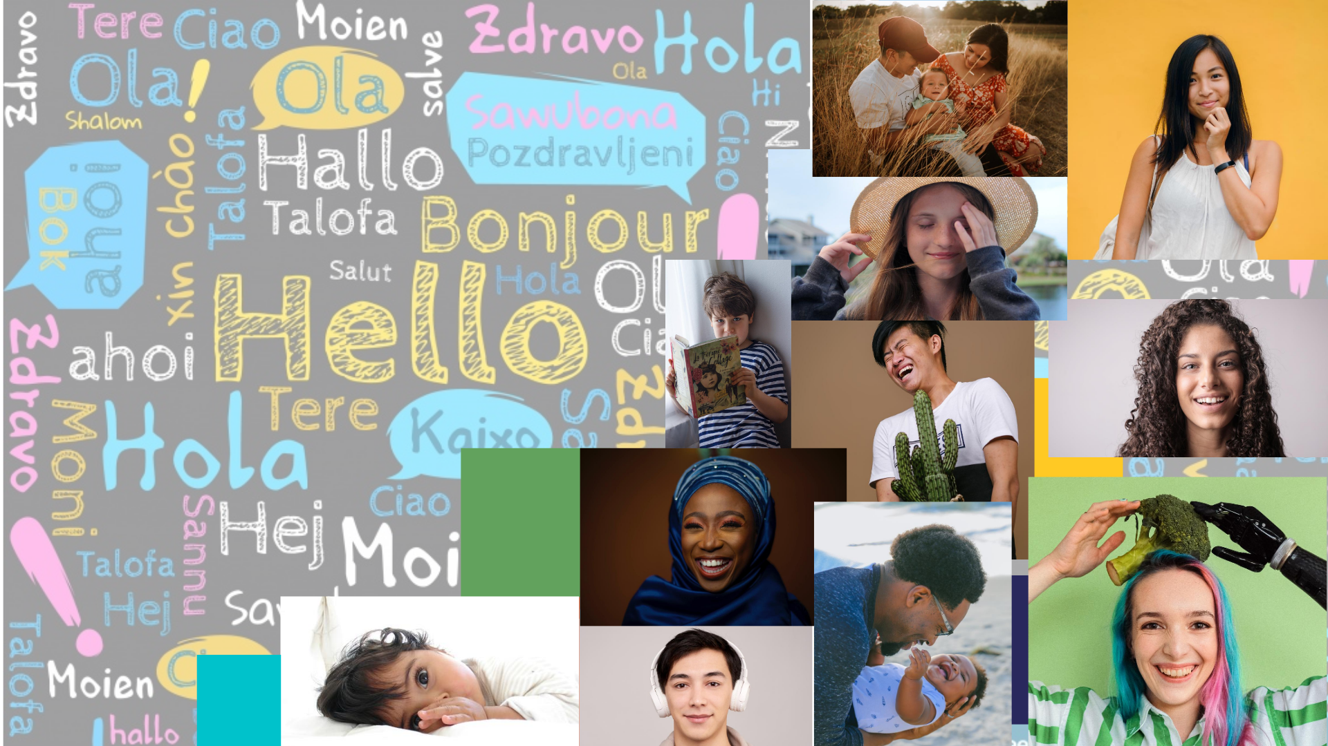

**Bilingualism & Cognition**

Mondays & Wednesdays | 12:30pm-1:45pm EDT | Georgetown University

Topics will focus mostly on infancy and childhood, but it will also include some adult research. You will be introduced to the debates in the field and its interdisciplinary nature, such as from the lenses of Psychology, Linguistics, Neuroscience, and Education.

Instructor Info:

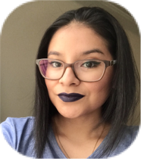**Instructor:** Joscelin Rocha-Hidalgo

**Please call me:** Joscelin or Prof. Rocha (pronouns: she/her/hers)

**How do you pronounce it:** Ro-cha the /ch/ is pronounced like the /ch/ in cheek

**E-mail:** [jr1679@georgetown.edu](mailto:jr1679@georgetown.edu) (expect a response within 24-48 hours)

**Student Hours:** Wednesdays, 3:30-5:30pm (link on canvas) or appointment [here](https://calendly.com/earlylearningproject/joscelin-office-hours)

**Topics we could talk about during student hours:** Anything related to the class,

becoming a Psy major, getting involved in research, grad school, scholarships and

fellowships, being first generation, learning to program using R, Bolivia, etc.

Course Agreements

## Course Materials & Resources

Readings and resources will be available on the course Canvas site. Prospective readings are listed below. Any changes will be posted on Canvas.

## Late Submission

For assignments that are submitted late, the maximum obtainable grade will be reduced by 10% for each day it is late. For instance, if one receives 9/10 points on an assignment that is three days late, one will receive 6.3/10 points instead.

## Appealing Grades

If you believe that an assignment deserves more credit than was awarded, you may appeal to the instructor for reconsideration. All such appeals (except for simple errors in adding points) must be submitted to me in writing **within one week of** receiving your grade. A second grading of your work may result in downward or upward changes in your grade.

## Extra Credit

You may earn extra credit up to 2% on your Research Proposal Assignment. There are two ways to obtain extra credit: Research Participation &/or Article Summary/Review. You may combine methods, for instance, by obtaining two research participation credits and doing one article review.

**Names, Pronouns, & Self-Identification**

I value our diverse student body and am committed to fostering an equitable classroom environment. I invite you, if you wish, to tell me how you want to be referred to both in terms of your name and your pronouns (he/him, she/her, they/them, etc.). Additionally, it is your choice whether you disclose how you identify in terms of your gender, race, class, sexuality, religion, and dis/ability, among all aspects of your identity. I will do my best to address and refer to all students accordingly, and I ask you to do the same for all of your fellow students.

**Course Etiquette**

**Be nice. Be honest. Don’t cheat or plagiarize.**

We will also follow [Georgetown University’s Code of Conduct](https://studentconduct.georgetown.edu/code-of-student-conduct/).

This syllabus reflects a plan for the semester. Deviations may become necessary as the course progresses.

**Learning during this Pandemic**



Life absolutely sucks right now. **I am fully committed to ensuring that you learn everything you were hoping to learn from this class!** I will make whatever accommodations I can to help you do well on your projects. Under ordinary conditions, I am flexible with grading and course expectations when students face difficult challenges. Under pandemic conditions, that flexibility is intensified.

You *never* owe me personal information about your health (mental or physical). You are *always* welcome to talk to me about things that you’re going through, though. If I can’t help you, I usually know somebody who can.

If you need extra help or need more time with something, or if you feel like you’re behind or not understanding everything, **do not suffer in silence!** Talk to me! I will work with you. **I promise.**

*Please* sign up for a time to meet with me during student hours. I’m also available through e-mail and Slack. I want you to learn from this class, but I primarily want you to stay **healthy, balanced, and grounded** during this crisis.

How Will your Success Be Measured?

**Attendance (0%)**

Attendance is not going to be monitored in this class. World is crazy right now to be worrying about it.

**Class Contribution (10%)**

While attendance is not required, I do expect you to contribute to the class.

It will be graded on how well prepared you are for the class meetings, appropriate contributions to both small and large group discussion, ability to respond appropriately to classmates' questions, comments and discussion. Appropriate contribution to only small groups will earn a "C". Appropriate contribution to both large and small groups will earn a "B". Superior participation in both large and small groups will earn an "A". Failure to participate in discussions will earn a "D" or lower. Consistent, inappropriate contributions will be penalized by one letter grade or more. I will inform you in private if I think your contributions are inappropriate.

Appropriate contributions include:

* monitoring the tone and the amount of your own speech
* allowing others a chance to speak
* facilitating others' contributions
* plus other definitions we may develop as a class throughout the semester

If **asynchronous**, you will be responsible for submitting a 1-page response to questions that were raised during the synchronous class (I will post them in Canvas after class). It will be due by the following class time (late submission rules apply). **OR** you can tweet about one of the articles due to be read that class. Your goal is to summarize what you feel is the main point of the article in 240 characters + image (#GUbilingcog). The tweet has to be posted that same class day but any time.

**Reading Responses (20%)**

For each class, you will submit a brief (1-2 page) response to the assigned reading. These must be submitted by 5:00pm on the day before class on Canvas. To receive full credit, these must show close reading and thoughtful engagement with the assigned reading for that day. **It is not sufficient to merely summarize the reading**. In other words, this is not an article summary; you have to explore your own idea(s) about the readings(think about what your thesis is and organize your writing around that thesis).

A high-quality Reading Response provides in-depth, thoughtful exploration of one or more ideas, clearly relates these ideas to the readings in a way that indicates close and careful reading, and is well-written (strong paragraph structure, clear and cogent use of language, free from spelling and grammar errors). Your response must make specific reference to the assigned reading for that day; it is not sufficient to just expound on your own ideas related to the topic. Some ideas for reading responses:

* Identify aspects of the reading with which you disagree and discuss why they are problematic.
* Discuss what most surprised you about the material in the reading and why you found it surprising.
* Discuss potential applications of the material in the reading – ways in which it applies to your own life or ideas for how to use the material in the reading to improve the quality of life more broadly.
* Limitations of the theories or research discussed in the readings and how these should qualify our conclusions.
* Ideas for new studies or theories in the field.
* The implications of the research with regard to current social or political issues.
* Was their evidence enough for their claims? What else would you have liked to see?

If you use direct quotations from the reading, be sure to put them in quotes. You don’t need to include formal citations or references in these responses, but you do need to be clear about which readings you are referencing, as there will be multiple readings for each class.

**Deadline is the same for both synchronous and asynchronous students.

**Article Summary (4%)**

At the beginning of the semester, you will sign up for 2 dates where you will be in charge of summarizing one of the articles we will read for that day. You will submit the summary as a video that I will show in class (unless you choose to present it live). An example of the summaries could be seen [here](https://www.brainpost.co/weekly-brainpost). More details about this can be found in Canvas.

*This assignment will help you build your public speaking skills and your ability to synthesize information.*

**News Critique (4%)**

For this assignment, you will evaluate the quality of a popular media representation of scientific research on Bilingualism & Cognition. More details about the assignment will be provided.

*This assignment will help you think critically about how science is being presented in media. Thinking about this is extremely important, considering that most of our society learns about science through the news and social media outlets.*

**Research Proposal Assignment (62%)**

This proposal will be scaffolded throughout the semester in the following ways:

1. **Topic Proposal + Annotated Bibliography (15%)**

For the proposal you will identify an open question in the field of bilingualism and cognition and write two to three paragraphs describing the question, explaining why it is important/relevant and discussing how you think scientific research can inform the question at hand.

For the annotated bibliography you should provide the full citation for 6 articles (APA format), a brief summary of each and a description of how you will use the reference in your proposal (does it describe a definition you need to explain?, provides evidence for a phenomenon?, etc.)

**2. First Draft of Proposal (15%)**

The research proposal will follow the NSF (GRPF) guidelines. Such guidelines will be shared on canvas.

**3. Peer Review (10%)**

Peer reviewers are the gate-keepers of science. When you write a paper or a grant proposal, it gets sent to fellow scientists (peers). They explain to you all the things you did wrong and well. If you can fix some things, your paper gets published (it becomes *canon*), or the grant gets funded (you get *money*). Clearly, the quality of science as a society-level endeavor depends on its peer reviewers; you will be assuming this role for your fellow classmates. After the first draft of your proposals is due, I will give you two proposals; you are to serve as the primary on one of these and as the secondary reviewer on the other. You will write a brief critique of both proposals you have been assigned. More details will be shared on Canvas.

**4. Peer Review Day Participation (2%)**

On this day, we would have enjoyed some donuts in class, but sadly not this year. Instead, we will meet via zoom. You get 2% for attending and presenting your summary (for asynchronous, you will send a video of you presenting). More details will be shared on Canvas.

**5. Final Draft of Proposal (20%)**

Taking the critiques and recommendations from your reviewers (including me), you will revise your proposal and submit it. This is due the day of our final (we don’t have a final exam for this class).

Where Can You Get Help?

* [Accommodations: The Academic Resource Center](https://academicsupport.georgetown.edu/)
* [CAPS: Counseling and Psychiatric Service](https://studenthealth.georgetown.edu/mental-health)s 202-687-6985 or after hours, call 202-444-7243 and ask for the on-call CAPS clinician
* [Center for Multicultural Equity and Access (CMEA)](https://cmea.georgetown.edu/#_ga=2.2156146.338741907.1597604147-463980031.1582147522)
* [Georgetown Emergency Response Medical Service (GERMS)](http://www.georgetownems.org/calling-germs/) For emergency medical care call 202-687-4357 (save this #)
* [Georgetown University Police Department (GUPD)](https://police.georgetown.edu/reporting#_ga=2.124379592.338741907.1597604147-463980031.1582147522)
* [Georgetown Wellness Wheel](https://studenthealth.georgetown.edu/Hoya-Wellness-wheel)
* [Writing Center](http://writingcenter.georgetown.edu/)
* [Health Education Services (HES)](https://studenthealth.georgetown.edu/health-promotion#_ga=2.161251839.338741907.1597604147-463980031.1582147522)
* [Health Education Services for Sexual Assault Response and Prevention](https://studenthealth.georgetown.edu/health-promotion/services-3/sexual-assault-relationship-violence/): confidential email [sarp@georgetown.edu](mailto:sarp@georgetown.edu)
* [Hoya Hub Food Pantry](https://studentaffairs.georgetown.edu/foodpantry)
* [La Casa Latina](https://cmea.georgetown.edu/casalatina/)
* [LGBTQ Resource Center](https://lgbtq.georgetown.edu/#_ga=2.69845330.338741907.1597604147-463980031.1582147522) [Title IX](https://titleix.georgetown.edu/#_ga=2.69845330.338741907.1597604147-463980031.1582147522)
* [Student Health Center (SHC)](http://studenthealth.georgetown.edu/medical-care#_ga=2.103393858.338741907.1597604147-463980031.1582147522)
* [The Black House](https://cmea.georgetown.edu/blackhouse/)
* [Women’s Center](https://womenscenter.georgetown.edu/#_ga=2.103393858.338741907.1597604147-463980031.1582147522)

I believe this section is very important, and in order to ensure y'all are informed with all these options, I would like you to do something. If you have read this far, I would like you to send me your favorite meme. I don’t care who or what it refers to, just email it to me or send it to me via slack. I am serious! You will lose a point from your first reading response if you don’t send me anything by August 31st. Now the important information…

If you experience sexual violence, identity-based harm, or any other personal crisis at any point during the course, please do not hesitate to reach out to (1) help you get caught up in class, (2) put you in contact with the appropriate resources and services, and (3) answer questions to the extent that I am qualified to do so. If you would rather not talk to me about these issues, I completely understand. Here are some of the resources I would have been sharing with you anyways.

I am committed to supporting survivors of sexual misconduct, including relationship violence and sexual assault. Due to federal law, I must report any disclosures of sexual misconduct to the Title IX Office. I want to be able to protect you as best as I can, and in this case, it would be to report the survivor’s story to the appropriate authorities.

## Basic Needs

Did you know that Georgetown University has its own food pantry? They have not only non-perishable food, but also personal hygiene products. During the period of online instructions, they relocated to McShain Kitchen, adjacent to McShain Large. You just need your go card to get in but if you encounter any problems getting in, just contact GUPD at 202-687-4343.

Course Schedule

|  |  |  |
| --- | --- | --- |
| **Week** | **Date** | **Topic (Assignment due)** |
| Week 1 | August 26 (Wednesday) | Welcome & Overview |
| Week 2 | August 31 (Monday) | Language Development |
| September 2 (Wednesday) | Critical Periods |
| Week 3 | September 7 (Monday) |
| September 9 (Wednesday) | Bilingualism in the U.S. & the World |
| Week 4 | September 14 (Monday) | Measuring Bilingualism (Children) |
| September 16 (Wednesday) | Measuring Bilingualism (Adults)  **(Topic Proposal + Annotated bibliography)** |
| Week 5 | September 21 (Monday) | Cognitive Flexibility & Language Control |
| September 23 (Wednesday) |
| Week 6 | September 28 (Monday) | Language Switching |
| September 30 (Wednesday) |
| Week 7 | October 5 (Monday) | Metalinguistic Skills |
| October 7 (Wednesday) | **(News Critique)** |
| Week 8 | October 12 (Monday) | The Brain |
| October 14 (Wednesday) |
| Week 9 | October 19 (Monday) | The Not-Too-Healthy Brain |
| October 21 (Wednesday) | **NO CLASS: Early Voting (DC, Oct 17-Oct 30)** |
| Week 10 | October 26 (Monday) | Executive Function |
| October 28 (Wednesday) |
| Week 11 | November 2 (Monday) | Social Cognition |
| November 4 (Wednesday) | **(First draft Proposal)** |
| Week 12 | November 9 (Monday) | Memory |
| November 11 (Wednesday) |
| Week 13 | November 16 (Monday) | Attention |
| November 18 (Wednesday) | **(Peer Review due)** |
| Week 14 | November 23 (Monday) | **NO CLASS: Thanksgiving Break** |
| November 25 (Wednesday) | **NO CLASS: Thanksgiving Break** |
| Week 15 | November 30 (Monday) | Policies |
| December 2 (Wednesday) |
| Week 16 | December 7 (Monday) | **OPEN** |
| December 12 (Saturday) | **NO CLASS: (Final Draft Due at 6pm)** |

Design of syllabus inspired by and adapted from Dr. Leslie Berntsen of USC ([@Leslie_bern](https://twitter.com/leslie_bern)),

Dr. Andrew Heiss of GSU ([@andrewheiss](https://twitter.com/andrewheiss)), & Dr. Deborah Stearns of GU [(@DeborahCStearns](https://twitter.com/DeborahCStearns))

